# Assignment 2

# Use an existing S3 bucket

1 file is older than 10 days and the other is not older than 10 days.

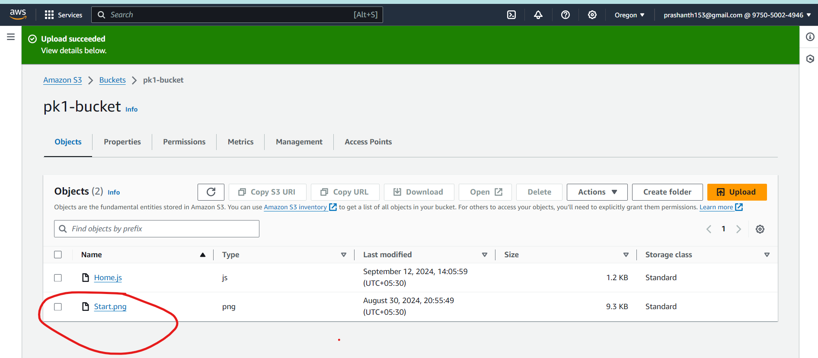

# Use an existing Ec2 full access role

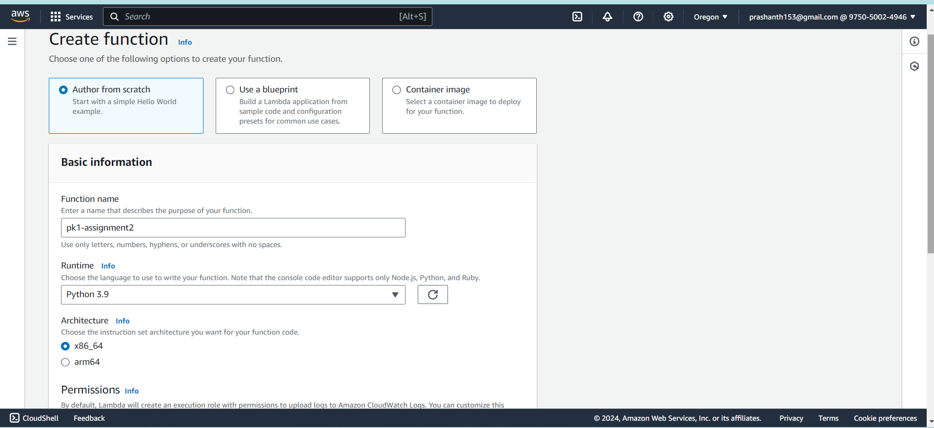

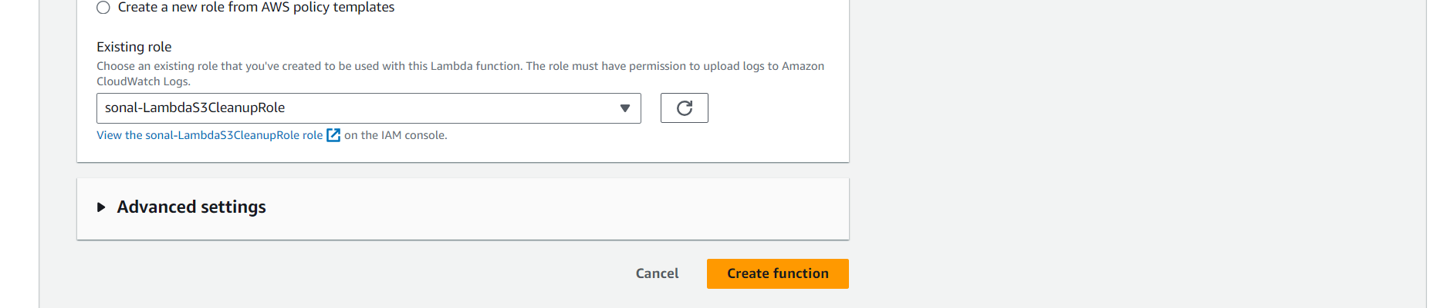

# Type the code for the Lambda function

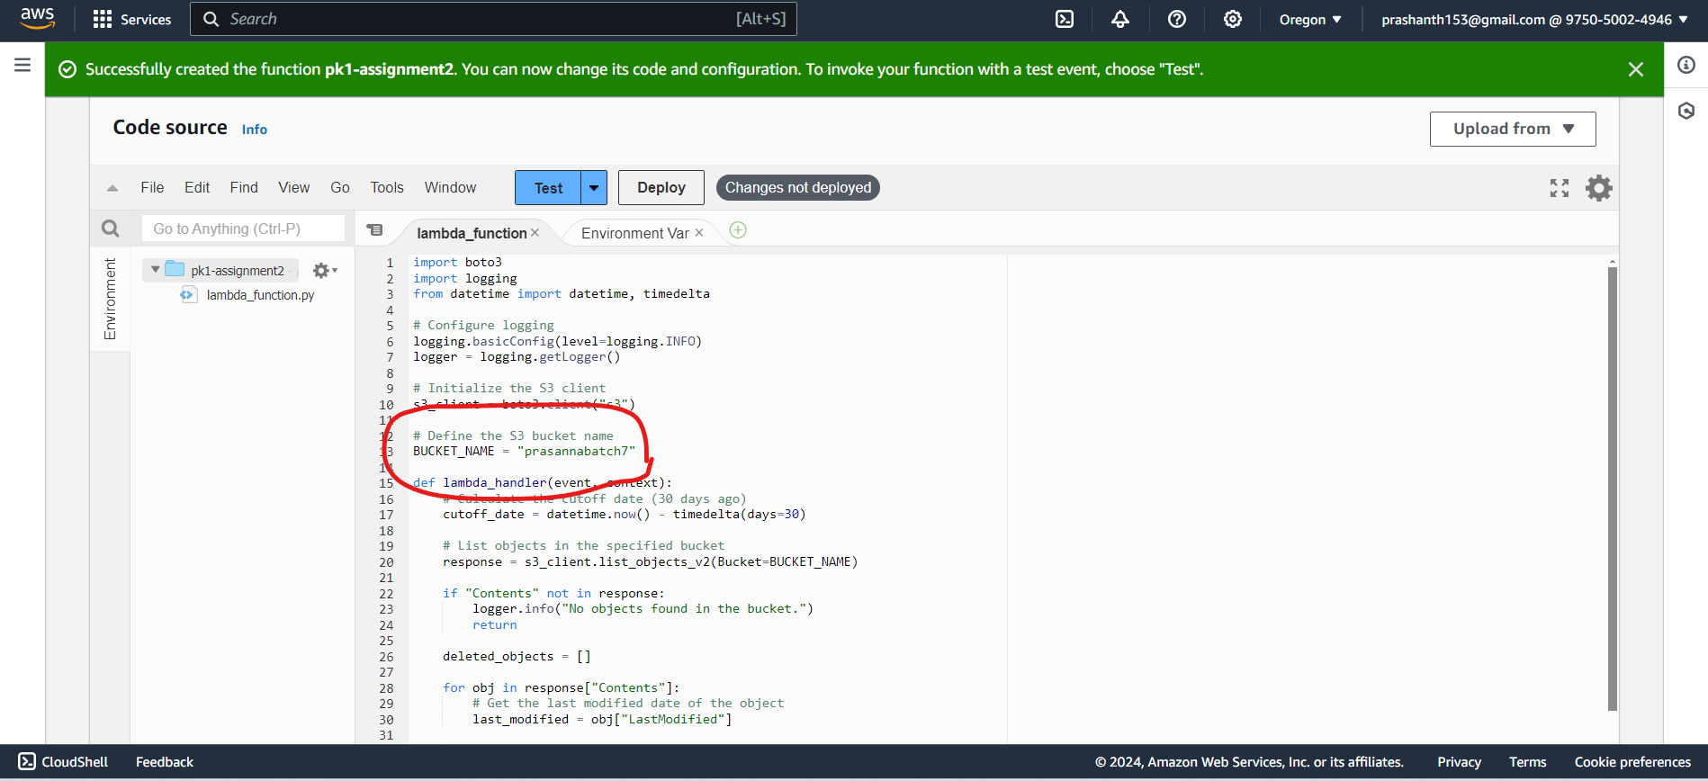

# Test if the lambda function works :

Yes worked successfully executed as shown below

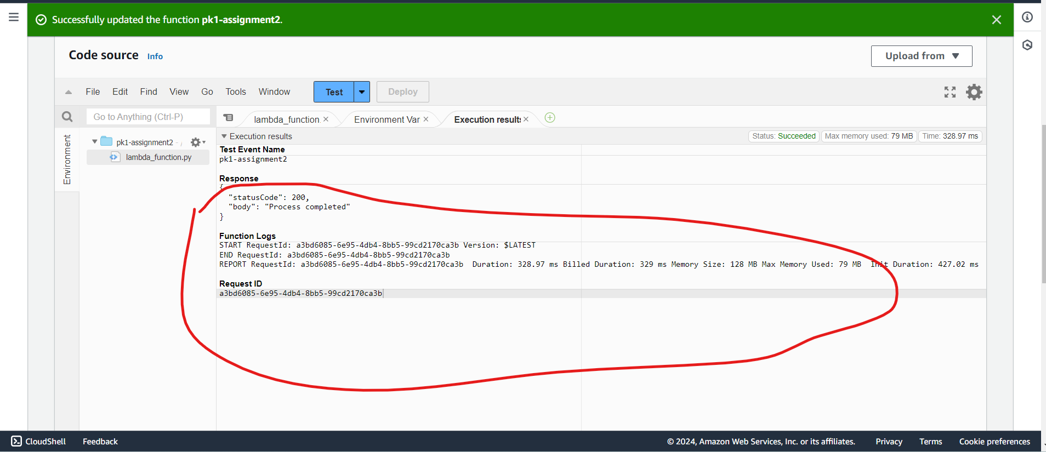

# Check if the older than 10 days is deleted from the bucket

Only the home.js is retained in the bucket as expected

